IV. Activities of the Regional and Sub-Regional Representations

5. Middle EAst Region
- Intoduction

The Middle East commission of the World Organisation for Animal Health (OIE), is composed from 20 member countries. Afghanistan, Bahrain, Cyprus, Djibouti, Egypt, Iraq, Iran, Jordan, Kuwait, Lebanon, Libya, Oman, Qatar, Saudi Arabia, Somalia, Syria, Sudan, Turkey, United Arab Emirates and Yemen. The Palestinian Autonomous Authorities are always invited as observer. Some of these countries (in red) are actually involved in other neighbouring regions.
The regional representation for the Middle East serves all the countries mentioned above and in many events jointly with the SRR of North Africa and SRR of East Africa.
Due to the political disturbances affecting the region, some of the planned activities, the RR ME has to overcome difficult challenges in the implementation of these activities. But, in general, the solid cooperation and good relationship with member countries, achieved a notifiable result.
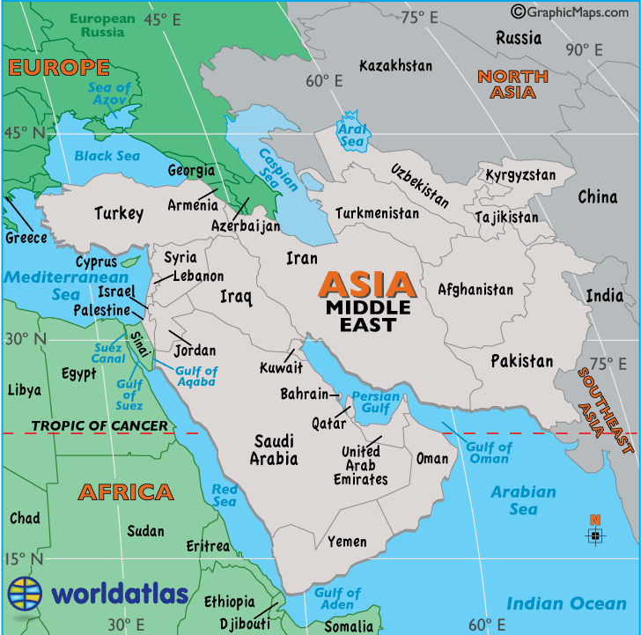

  - Objectives

The primary objective of the RR-ME is the support to strengthen the Veterinary Services’ capacities in the Middle East countries in the control of animal diseases and zoonoses, in compliance with the OIE strategic plan, which includes:

- Supporting the animal disease information system and promote compliance,
- Establishing cooperation and harmonisation of strategies between the countries of the Middle East, especially in priority diseases control programs,
- Strengthening collaboration with regional and international organisations, reactivation of the regional GF TADs, collaboration on AMR
- Holding conferences and seminars that will be targeting specific issues related to animal and public health, especially training seminars for focal points,
- Promoting the capacities and capabilities of regional laboratories and coordinating their activities. Consider networking.

The major animal diseases in the region, as identified in the regional GF TADs action plan, are:
- FMD and PPR still the two main constraints affecting livestock production in this part of the world and remains a significant drain on the budgets of the national Veterinary Services of each country. The RR with the collaboration of the new SRR in Abu Dhabi will focus on encouraging, assisting countries (the majority in PCP stage 2) to progress to stage 3 for dossier recognition in near future (2022).
- In terms of Veterinary public health, brucellosis and rabies, are affecting the majority of the regional countries. Regional plans for the control of these two diseases are in progress to be submitted to regional countries. The year 2020 will be announced as “Towards Rabies free year.
- Due to the particularities of the Middle East in terms of animal imports, animal trade is a potential route for the introduction of exotic diseases into the region. The RR ME and the SRR AD will work together to promote the BESST initiative and the search for resources, so to contribute on facilitating safeguarded trade between the concerned regions. Also the RR will continue to assist in the establishment of free diseases zones/compartments and the safe movement of HHP horses.
- Main risks concerns vector borne diseases such as Rift Valley Fever, Lumpy Skin Disease and Bluetongue. The RR will approach this concerns with high importance.
Besides the above, specific activities are devoted to avian, equine and camel diseases which require continuous attention in the coming years.

- Human resources

The RR-ME has a staff composed of 3 veterinarians:
- the OIE Regional Representative,
- a mid-time veterinary officer “chargé de mission” appointed by the Lebanese Ministry of Agriculture.
- a veterinary consultant, who is also webmaster for the RR-ME website.
The administrative staff is composed of a trilingual secretary, and two assistants.

- General financial considerations

The funding of the RR-ME depends on an annual voluntary contribution by the Lebanese government and part of the annual contributions to the OIE paid by Members in the region.
However, in view of the fact that there are only 13 Members geographically in the OIE Regional Commission for the Middle East, and that most of these Members are not in the highest contribution categories. The part of regional Members’ contributions is not sufficient to cover the annual budget the RR-ME needs to implement its activities’ programme.
Fortunately, most of the workshops, seminars and conferences organised by the RR-ME are sponsored, chiefly by the OIE World Animal Health and Welfare Fund and a generous contribution of the host countries.
As much as possible, joint meetings are also organised with our regional partners, FAO and WHO.
- Activities Carried Out In The Region During 2019

  - Strategic Objective 1: Securing Animal Health And Welfare By Appropriate Risk Management

    - Supporting the OIE Mandate in International Trade Standards:
- The RR ME is committed in encouraging Member Countries to participate effectively in the standard-setting process. In line with this objective the RR supported the annual meeting of the new delegates, and stress on periodical other meeting/s, especially in marge of major events, in order to build a common position for the region prior to the General Session of the World Assembly of OIE Delegates.
- Wherever necessary, the RR also reminded all concerned stakeholders, during meetings, seminars and official speeches, to use the OIE international standards (OIE Codes and Manuals) in developing national regulatory documents.
The Representation is also engaged in providing Member Countries with:
- Communication with the Bureau and OIE Delegates to ensure clear understanding of the new process being implemented for the election of members of the four Specialist Commissions.
- Dissemination the Call for Experts for relevant Commissions to scientific and technical contacts within the region.
- Exploring mechanisms for facilitating Member Countries’ engagement in the process for developing and updating standards.
- Translate relevant reports/documents/concept notes, into Arabic to assist Delegates with preparation of comments.
These objectives have been translated to reality by the following activities:
- Seminar on OIE standards. Facilitating International movement of competition horses with identification of the obligations of the veterinary services, the sport federations and the customs, have been held in Rabat-Morocco and Beirut Lebanon.
- In general, in all events organized by the RR, there is always explanation, clarification on the necessity to comply with the OIE standards.

    - Supporting the OIE Mandate in Official Disease Status Recognition:

The RR ME aimed always to:
- Promote engagement of Member Countries into the Official Status Recognition Procedure.
- Assist Member Countries in preparation of applications on the procedure, on the requirements of the Terrestrial Code
- Coordinate with the HQ Status Department in timely submission of Annual Reconfirmations of official status/endorsed control programmes from Member Countries.

Hence, the region is endemic for major diseases, as described in the introduction, but coordination is conducted for regional approaches and joint action plans for the containment/eradication of major diseases.

Some countries are also looking to follow procedures of self-declaration of freedom from non-reported diseases in the country.

AHS is actually the only disease which requires official recognition from the OIE. Saudi Arabia, Lebanon and Syria have developed dossiers for this purpose, but still some requirements needed.
- The new concept of HHP, is also very well welcomed in regional countries to facilitate movement of valuable horses. The seminars in Rabat and Beirut, also discussed on how to submit AHS dossier for official recognition of status, and the establishment of EDFZ for HHP horses.

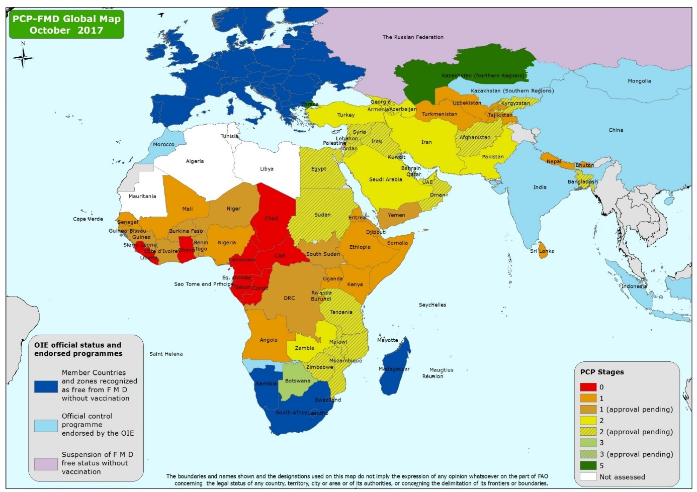

    - Supporting the OIE Mandate in Coordination of Disease Control/Eradication.

The animal diseases of particular concern in the region are FMD, PPR, Sheep and Goat Pox, Brucellosis, Rabies, contagious caprine pleuropneumonia (CCPP), Rift Valley fever (RVF), lumpy skin disease (LSD), highly pathogenic avian influenza (HPAI) and Newcastle disease (ND).

Camel and Equine diseases are also of major concern.

The main aquatic diseases of concern are the White spot Syndrome and epizootic ulcerative syndrome.

The actual occurrence of these diseases or the threats that they pose are less reflected in the number of immediate notifications made to the OIE. Countries in this region are generally reluctant to consider immediate notifications, arguing that most diseases are endemic and notification might be not well understandable by the trade partners.

In this regards, the OIE Beirut office stimulated all along the year and facilitated support to countries for the continuous assessment of the countries status concerning major diseases such as FMD and PPR, following the guidelines of the relevant International Organisations, in particular the GF TADs meetings. The RR ME with the collaboration

- The 15th conference of the OIE regional commission for the ME, to be held in November 2019, in Abu Dhabi will be a platform to discuss future activities and to promote initiatives and programs as identified above.
- Back to back with the conference, a seminar on the implantation of OIE standards will be held for delegates and their concerned staff.
- As mentioned above, a major task for the RR and SRR, is to encourage and assist countries in the progress in FMD PCP pathway in order to submit collectively their dossiers to the OIE for official recognition as soon as possible.

    - Support for national and regional initiatives by the OIE and by the Tripartite partners (FAO and WHO) on the fight against antimicrobial resistance, including the global database on antimicrobial use

Achievement of the OIE objective of animal disease control and eradication is threatened by the emergence of resistance of microbes to antimicrobial agents (antimicrobial resistance [AMR]).

In the animal health sector, AMR challenges include usage of drugs by untrained personnel, the use of counterfeit drugs and the unnecessary prescription of antimicrobials, even where there are alternatives such as vaccination.

The OIE, WHO, FAO and other stakeholders have joined forces under a One Health approach to fight this scourge.

The RR and countries representatives attended the main events organized by the OIE on AMR, and the RR and SRR will organize early 2020 the seminar to discuss progress in this field and train focal points of VMP on pharmacovigilance.

    - Supporting the OIE Mandate in Animal Welfare

By identifying opportunities to support member countries in the implementation of the Regional Animal Welfare Strategy.

A regional Advisory Group has been formed to promote and follow up in 2017. The strategy is based mainly on the OIE code chapters on transportation by land and by sea, transportation to slaughter and the stray dog’s control.

A roadmap for the implementation of standards on Transport by land and by sea, from the origin to destination, is prepared jointly with SRR Brussels and the HQ. The modules were presented in a cycle of working sessions, involving six countries in the region in 2018, and 3 other training the trainers sessions on animal welfare during transport by land and by sea have been held successfully in Muscat Oman in 2019.
A seminar on animal welfare in transport “Whole Journey Scenario” in middle east will be held in November 2019 and be followed by another in 2020 with the support of the EU agencies.

The aim of training programme is to improve welfare of farm animals prior to and during long distance transport in selected eligible member countries by the tailored, training-the-trainers programme developed to support implementation of the OIE animal welfare standards.
Training materials cover the welfare of the animals mostly in relation to long distance transport, but also could be applied for short distance transport. The materials address the welfare of cattle, sheep, horses and poultry during transport with focus on animals transported for slaughter.

Countries in the region started to develop national strategies in compliance with OIE standards (Lebanon and UAE).

  - Strategic Objective 2: Establishing Trust Through Transparency And Communication

    - Supporting the OIE Mandate in International Disease Transparency and Reporting:

The RR will:

Continue to disseminate information and promote WAHIS by using various media of communication (WAHIS video, PPTs with WAHIS data, etc.).

Other activities undertaken to improve the situation were to:

Provide technical advice on request to Member Countries on disease reporting; and - Remind, from time to time and during various meetings,

The Representation participated in the modernisation of WAHIS and WAHIS plus, by informing Member Countries to submit their needs for WAHIS to the OIE.

Several meetings been organised to promote WAHIS at Veterinary Education Establishments (VEE) within the region using information from OIE database on VEE. An Arab veterinary institutes committee has been established to promote transparent reporting and information sharing.

Follow up Delegates of Member Country`s with important and relevant unofficial animal health information published in media but not notified to OIE.

    - Supporting the OIE Mandate in Animal Health communication.

A new website is in progress and will be ready to start by 2020,The RR participate in the collection, production and dissemination of communication products on both global and regional activities, and the majority is shown on the regional website, and through specific messages during regional events.

The RR is also working on initiating a regional Communication Focal Point network, with the development of a list of regional contacts to improve dissemination of information on the various veterinary fields, and to ensure the consistency of OIE image within the region and develop the OIE visibility.
- The modernisation of the regional website and enlarging its areas of data will be a priority task to be accomplished in 2020.

The RR is also aiming to reinforce the links between the OIE regional and global websites as well as with other organizations and agencies.

  - Strategic Objective 3: Ensuring The Capacity And Sustainability Of Veterinary Services
    - Supporting the OIE Mandate in Strengthening Veterinary Services through the OIE PVS Pathway:

The RR:

Continue to advocate with Member Countries to request PVS missions. 3 requests for PVS missions are noted to be followed as soon as convenient: Egypt, Iraq and Lebanon.)

Explore and develop opportunities within the region, in liaison with RAD, for progressing PVS-IHR collaboration with the WHO and interested member countries. Four assessment missions been conducted in the region with WHO and useful outcomes been concluded.

    - Supporting the OIE Mandate in Strengthening Veterinary Services outside of PVS.

The RR worked to:

Support the development and organisation of Focal Point Seminars and other capacity building workshops/seminars following established procedures. Seminars for focal points been successfully organised for Animal welfare, WAHIS,. Seminars for focal points on communication, VMP and aquatic animal diseases are planned for 2020.

Provide support and assistance to specific regional concerns implementation, such as: EDFZ in Syria, HHLEZ in Jordan.

The RR is successfully promoting the OIE Twinning Program to member countries. Twinning programs are in process: Epidemiology and risk assessment (KSA- Teramo), FMD (KSA Brescia), PPR (Kuwait CIRAD), AI lab (Lebanon-UK

The RR is also supporting activity in other OIE priority areas of VS strengthening, including promoting and implementing OIE guidelines and other documentation targeting Veterinary Educational Establishments, Veterinary Statutory Bodies, the role of veterinary paraprofessionals, management of Veterinary Services, etc.

  - Cross-Cutting Area A: Scientific Excellence

The Region is committed to promote scientific excellence in the Middle East. The initiatives of CAMENET and AQMENET, and the several twinning projects, especially those on Epidemiology (KSA) and veterinary education (Jordan and Egypt), are a few examples of this commitment. They are fully supported by the Representation.

The RR continue to work on establishing permanent relationships at regional level with tripartite partner organisations FAO and WHO and promote tri-partite approaches to key issues especially on AMR, Rabies, Brucellosis, AI, RVF. The RR is also working to povide advice with identification of regional experts/networks for vector borne diseases with a special focus on RVF and LSD.

The RR maintain a regional brief on developments and activities involving MERS CoV as a priority One Health issue, particularly at its intersection with camel health. In this regards an FAO-OIE-WHO Global technical Meeting on MERS-CoV was held in Geneva Switzerland September 2017. The RR and representatives from member countries participated and the intervention on the research conducted in UAE and KSA was much appreciated.

  - Cross-Cutting Area B: Diversity, Inclusiveness, Engagement, Transparency

The overarching principles of diversity, inclusiveness, engagement and transparency are critical in increasing the participation of developing countries in the Middle East in the activities of the OIE. These principles are applied with all activities undertaken by the RR as part of the OIE Sixth Strategic Plan. In this perspective, every Member Country is engaged and can contribute, irrespective of size or level of development.

In line with this principle, the RR will continue to submit names of experts to be proposed by the OIE Delegates whenever nominations were requested for OIE Ad hoc Groups, Working Groups and Specialist Commissions.

This principle is also applied during the process of the election of new members of the OIE Council and the Bureau of the Regional Commission.
  - CROSS-CUTTING AREA C: GOVERNANCEAND RESOURCING.

    - Liaison with the Regional Bureau and Regional Commission Conferences.

The Bureau of the Regional Commission for the Middle East was consulted on all issues relevant to the Region. The contribution of the new elected president of the commission, Dr Elias Ibrahim, delegate of Lebanon is highly appreciated for his continuous support to the RR office in Beirut. We are very .thankful for his work to allocate a new offices in Hazmieh.

The RR is continuously in contact with members of the bureau as well as other delegates in order to: improve the dialogue within the bureau and the delegates, and maintain a good relationship with decision makers with the majority of member countries.

The RR regularly shares the programme of activities of the region with the Members of the Bureau for their advice.

Provide technical support in collaboration with the Members of the Bureau for the development of the agenda of the Regional Conferences and other events.

Ensure the selection of Technical Items for Regional Conferences in line with the OIE Strategic Plan and the region’ concerns.

Provide technical support to the speakers of technical items of Regional Conferences for the development of Questionnaires, data analysis, and draft recommendations, as well as support for the development of presentations in line with OIE vision.

Ensure the follow up and encourage the implementation of the recommendations of Regional Conferences at regional level, in collaboration with the Members of the Bureau.
    - Liaison with Other OIE Regional and Sub-regional Offices

The RR continues to:

Develop strong formal and informal coordination and communication mechanisms between the offices with neighbouring regions/sub regions to clarify roles and responsibilities and avoid both gaps and duplication.

Share systematically the reporting of the activities of the ME region with other regions/sub regions.

Suggest meetings where opportunities arise with other regions to share perspectives and ideas.

All the above actions are regularly conducted especially with the neighbouring SSR of North and East Africa, (Seminars on Wildlife, WAHIS, AW, REMESA), as well as with Brussels office (AW, REMESA).
-Under the auspice of the co-presidency of Egypt and Cyprus, the Joint OIE and FAO secretariat (based in Tunis) – organised in collaboration with both Authority the 17th and the 18th meeting of the REMESA Joint Permanent Committee.
REMESA remains an official platform of considerable importance to allow Mediterranean countries to share and plan activities in the field of animal health and public health veterinary in order to control trans-national diseases and to increase mutual trust among the various countries.
The meeting was therefore an opportunity to update the epidemiological situation in the Mediterranean for some specific diseases considered to be priority for the network such as foot-and-mouth disease, PPR, rabies and avian influenza. Additional information was provided on bluetongue, lumpy skin disease and MERS-CoV
The RR participated actively in presenting the FMD and PPR situation in ME countries, as well as brief summary on LSD circulation. The RR also requested member countries to consider the importance of aquatic and marine species diseases in the Mediterranean in the next REMESA meetings.
    - Support to GF-TADs at Regional Level:
The RR will continue to provide secretariat support to drive the activities of the Regional GF-TADs Steering Committees to partnership with FAO in coordinating regional disease control and eradication, against agreed GF-TADs recommendations and performance indicators, and particularly in support of the Global Strategies.The next meeting is considered to be held in Djeddah, KSA in March 2020.

    - Liaison with International Partner Organisations

The RR is always keen to:

Arrange regular meetings with OIE’s international and regional partner organisations, mainly with the regional offices of FAO and WHO in Cairo, and exploring the development of new cooperative agreements where beneficial. The RR is looking forward to update the agreement with the Arab Organisation for Agricultural development (AOAD), based in Khartoum-Sudan, in order to join efforts for the implementation of projects of common concerns. A visit General to Khartoum to discuss this issue and renew relationship with AOAD, is planned for Nov 2019.

A similar approach will be conducted with other regional agencies such as the GCC animal health commission and the Islamic development Bank, both based in KSA.
    - Human, Physical and Financial Resourcing

Resourcing of Beirut OIE RR Office:

The RR will:

Undertake advocacy as necessary relating to the physical and financial resourcing (and related administrative/diplomatic arrangements) for the RR office within Lebanon.

Undertake mapping of existing and needed human resources (including skills/experience) within the RR Office.

Promote with delegates the mutually beneficial opportunity of placing secondees within the RR office by developing a brief communications ‘package’ document which highlights the benefits and develops proposed arrangements.

Meet all financial reporting and accounting requirements working in close collaboration with the OIE Financial Directorate.
    - General OIE Resourcing in the Region

For this purpose the RR will:

Use any opportunity to promote to OIE delegates and/or more senior officials the need to fully and promptly pay their annual OIE subscription fee at an appropriate level for their country, and considering the opportunity of voluntary subscriptions.

Assist with the mapping of resourcing needs in ME region (as aligned with targeted OIE priorities).

Undertake mapping of possible partners in the region (for possible joint proposals/programmes).

Undertake impact mapping of possible beneficiary stakeholders in collaboration with Country Delegates.

Prepare guidelines for fund raising with relevant partners/donors, including possible “marketing packages”.
- CONCLUSION:

The period 2018-2019 was full of activities aiming on providing support to strengthen the capacity of the Veterinary Services through continuous communication with OIE delegates of member countries, holding training seminars for focal points and organising relevant meetings on regional concerns (Camels, Equines, specific diseases).

The RR also worked with member countries to facilitate PVS missions report implementation and encourage twinning projects to national laboratories and veterinary education institution.

The implementation of the OIE standards, increasing participation in WAHIS and the participation of the delegates in the discussion of these standards took also a wide space in the activities of the RR and will continue in the years to come.

---------------------------------------------------------------------------------------------------------------

